**LINEAR REGRESSION**

**GEOMETRIC INTUITION BEHIND LINEAR REGRESSION**

# Linear Regression is one of the Regression Technique where y $∈R$ i.e Real number instead of a class label

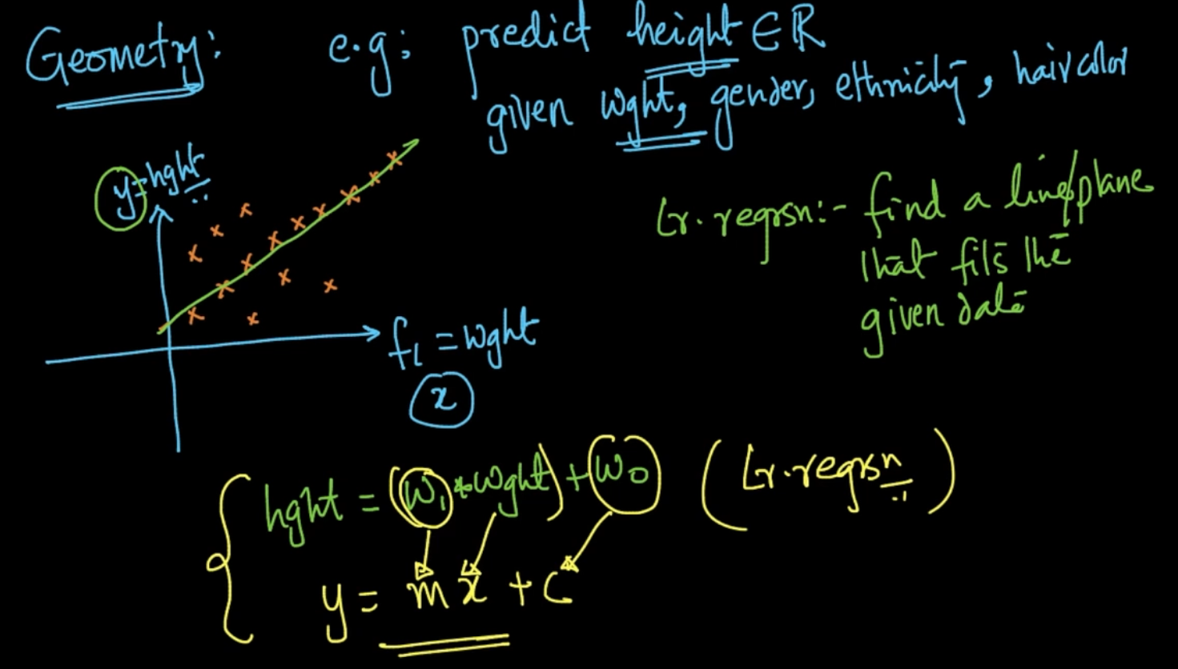

In Linear Regression we want the find the line which fits the given data. Ex: We want to predict height (y) given our features and we are using our feature weight (x).

Height = $w_{1}$* weight + $w_{0}$ (Linear Regression). In this algorithm our goal is to find $w_{1},w_{0}$

which can be compared to m(slope) and c(y-intercept) respectively

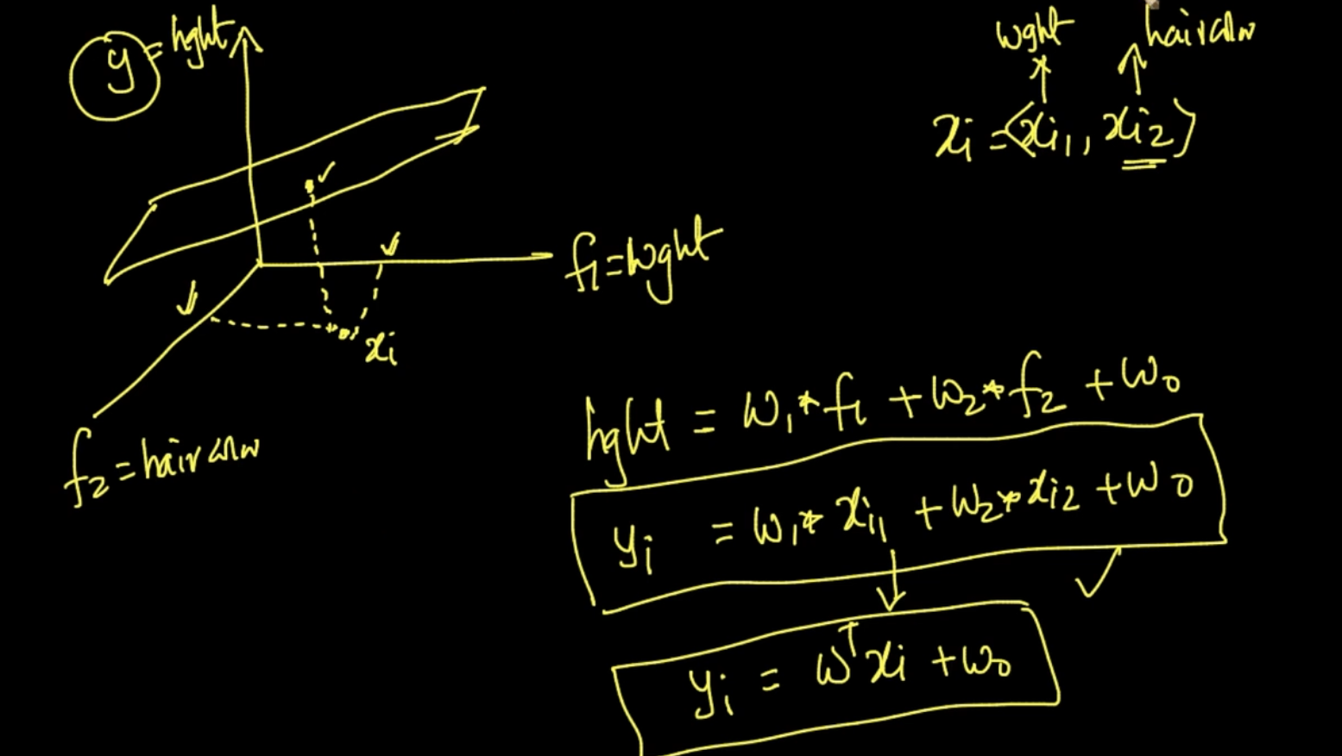

If we are predicting using two features. We’ll plot the point using them and see their value in the plane .That’ll be the value of y . In the above example, height = $w_{1}*f_{1}+w_{2}*f_{2}$ + $w_{0}$

Therefore, if we want to predict $y_{i}$ it’ll be $y_{i}$ = $w_{1}*x_{i1}+w_{2}*x_{i2}$ + $w_{0}$ => $y_{i}$ = $w^{T}x_{i}$ + $w_{0}$

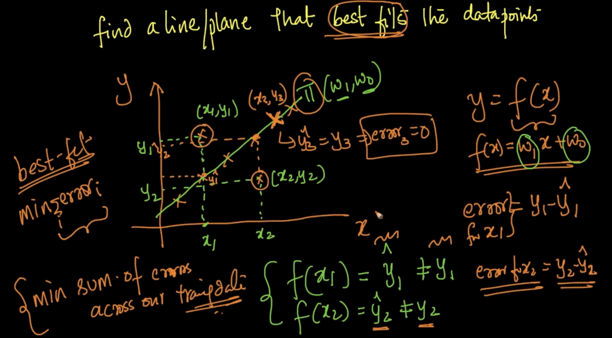

We’ve found the best fitting line to the data points i.e we’ve found $w_{1},w_{0}$.We’ve a point

($x_{1},y_{1}$) as we can see it’s not lying in the line .If we apply our algorithm f($x_{1}$) = $\hat{y_{1}}$ $≠y_{1}$.

So, it’s an error as predicted is not the same as actual label.Therefore, error = $y_{1}$- $\hat{{ y}_{1}}$

We want to minimize the sum of errors across our Training Data

**MATHEMATICAL FORMULATION**

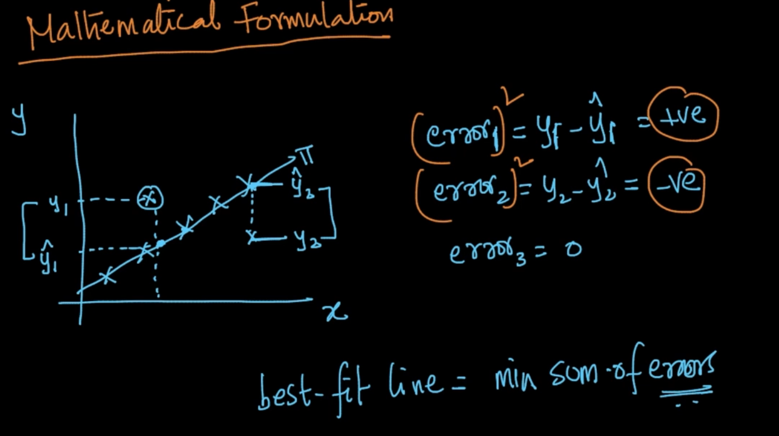

$\hat{y}$ is our predicted value and y is the actual value and their difference is erroe. As seen it can be +ve or -ve so we’ll square them up as we want the minimum sum of errors.That would be our best fit line

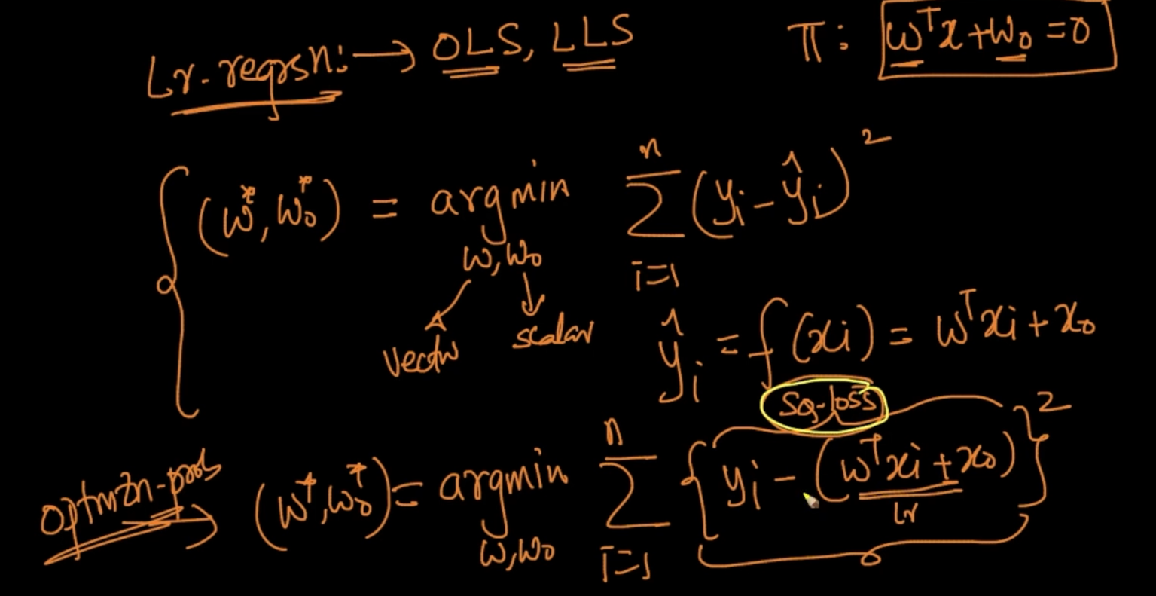

We want to minimize our w, $w_{0}$. In our optimization problem we want to minimize the squared error (y - $w^{T}x$ + $w_{o}$) $^2$. That’s our linear regression

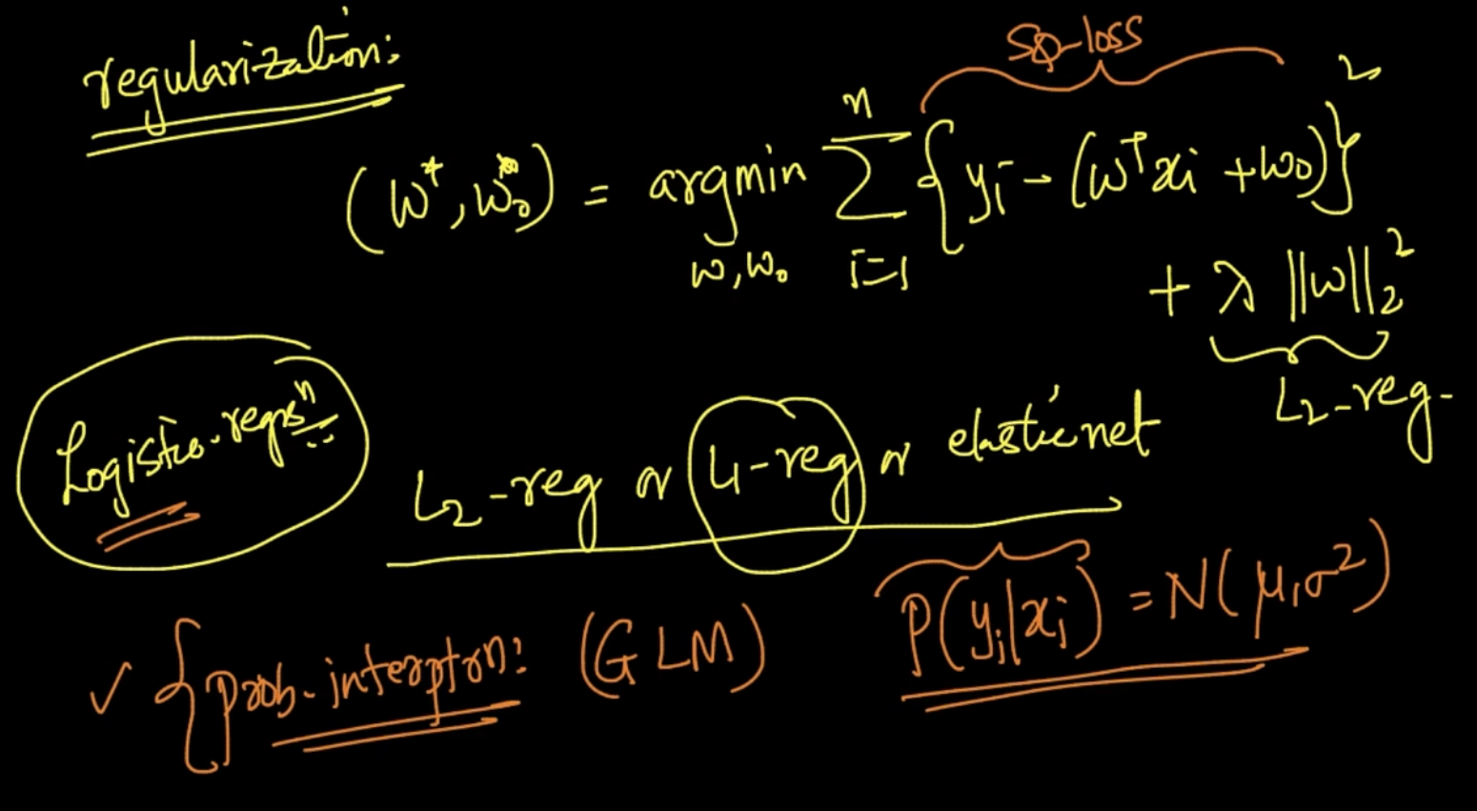

We are adding Regularization to our Linear Regression

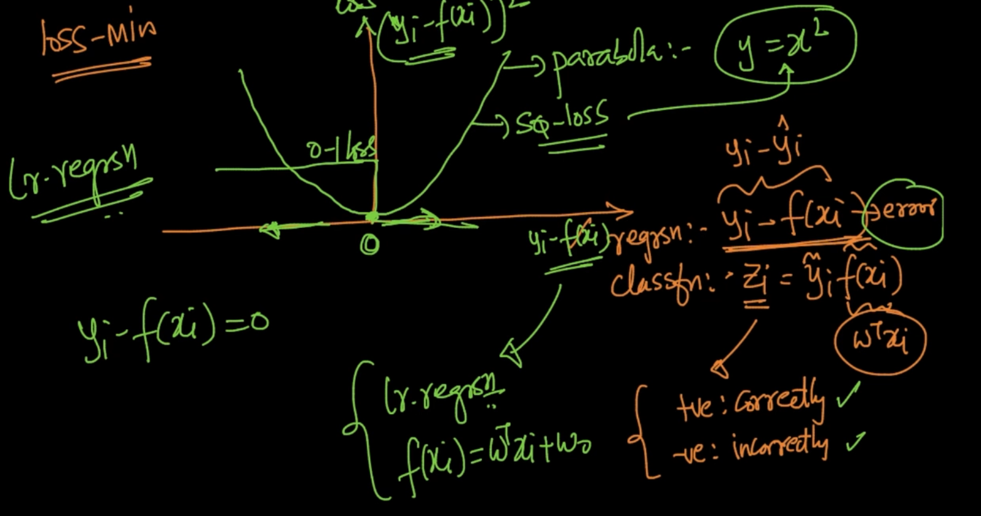

In Linear Regression, in our loss-minimization graph our x-axis = y - f(x) ,y-axis = ${(y - f(x))}^{2}$

It’s a parabolic function .If the error is 0 then the loss is 0 but as the data point moves away from the hyperplane the loss increases

**REAL WORLD CASES**



All the things are done in the same way as Logistic Regression as seen above

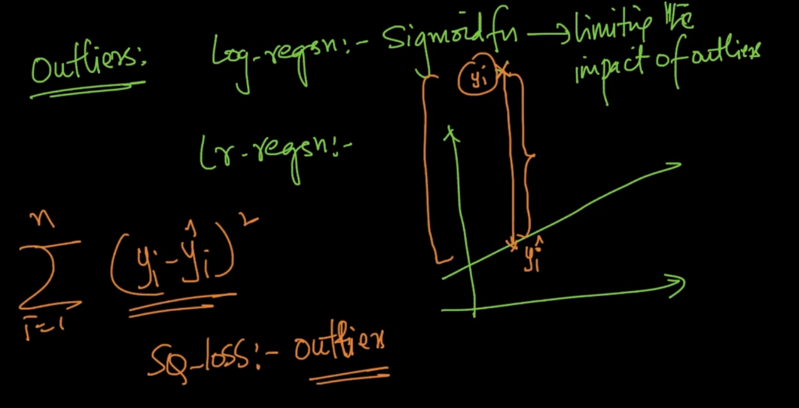

If an outlier occurs, as seen the predicted label $\hat{y}$ and the actual value y. The difference between them is huge and we apply squared loss for optimal w , So the squared loss would create a massive effect in our y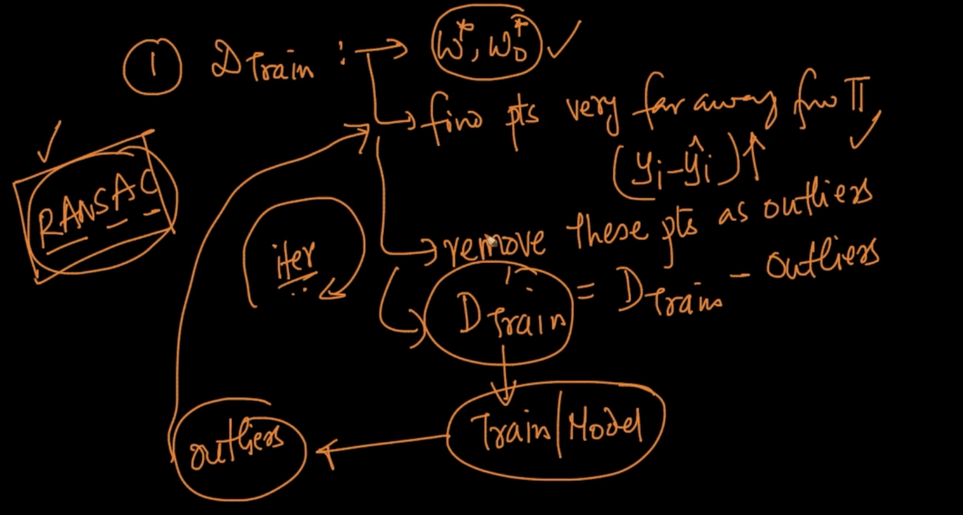

So we find our optimal w. Find points that are very far away from (y - $\hat{y}$) and remove these points and create a new training set. Repeat the process to deal with outliers